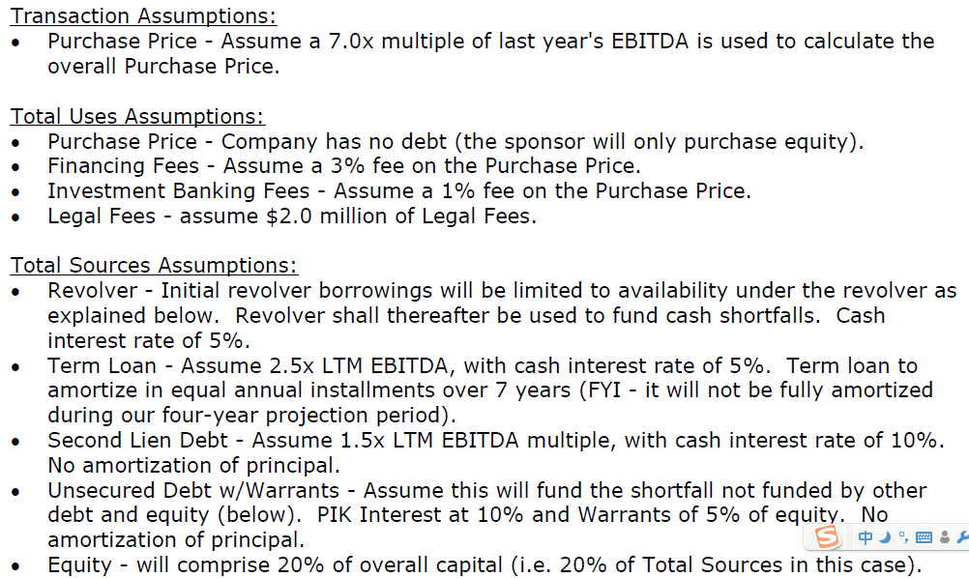

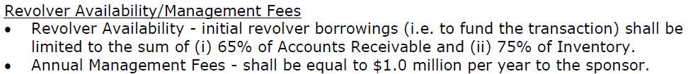



Next, I generated the Pro Forma balance sheet for Company B. 2008 historical balance sheet has been populated. In the pre-transaction column, it is assumed that the seller (i) takes all cash out of the company before the sale; and (ii) pays off all Company B debt prior to the transaction.



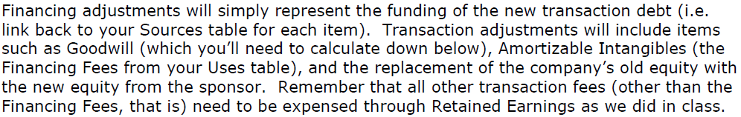





Reasonable assumptions create valuable projection models.

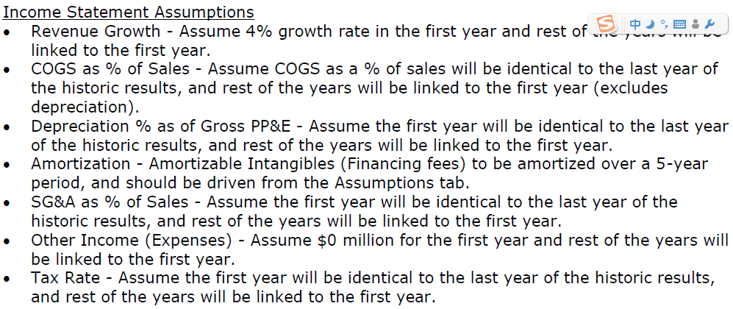

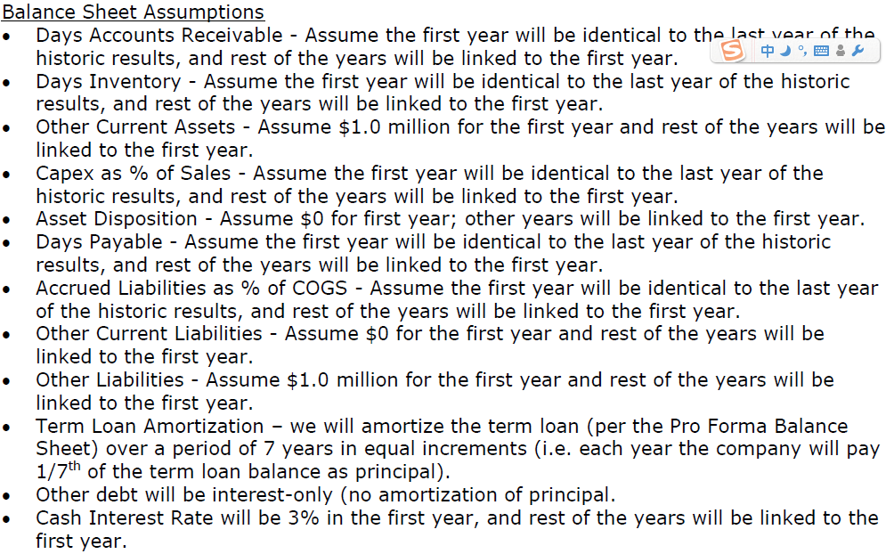



In the model section, 2003-2008 financial statements have been populated. Inserting 2008 Pro Forma balance sheet and linking assumptions to the model, I projected 2009-2012 financial statements for Company B.









Future financial statistics are calculated in terms of the model.



According to the projected data, Company B’s leverage is going to slide down after the transaction. Two primary reasons are (i) EBITDA will go up as revenue is assumed to increase by 4% each year and (ii) total debt would decrease by term loan amortization.

Assuming the financial sponsor sells Company B in 2012, how much would it earn from the investment? Would this transaction be a good deal for the financial sponsor?



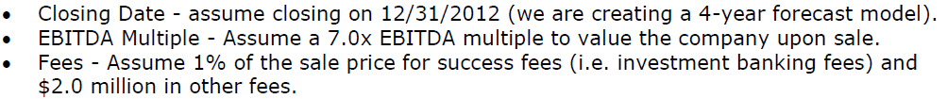



According to the above table, the internal rate of return to the financial sponsor is 13.9% by assuming a 7.0x EBITDA multiple and a 20% equity investment as % of total capitalization, and 11.5% for the unsecured lender. To see how these two factors would contribute to the financial sponsor’s IRR, I set up a sensitivity table as the following. It indicates that both factors are negatively related to the IRR. Theoretically, the lower the EBITDA multiple and the lower the equity investment percentage, the higher the IRR to the financial sponsor (opposite for unsecured lenders). However, the solvency risk to the acquirer would also climb up along with the increase of its IRR, and too much debt would make lenders doubt acquirer’s repayment ability and scare away potential lenders. Thus, acquirers have to tradeoff between risks and returns.

Sensitivity Tables

